**📑 Telco Customer Churn Analysis Report**

**1. Introduction**

The telecommunications industry faces a significant challenge in customer retention. Customer churn, which refers to customers discontinuing their service, directly impacts revenue and long-term growth. This report analyzes the Telco Customer Churn dataset to explore demographic factors, service usage patterns, account information, and their relationship with churn. The objective is to identify key drivers of churn and provide actionable insights to reduce customer attrition.

**2. Data Overview**

The dataset contains **7,043 customer records and 21 attributes**, covering demographics, subscription details, account information, and churn status.

* **Target Variable**: Churn (Yes/No → encoded to 1/0).
* **Preprocessing Steps**:
  + Converted TotalCharges from object to numeric.
  + Dropped 11 rows with missing TotalCharges.
  + Removed customerID (irrelevant).
  + Created dummy variables for categorical attributes.

**3. Exploratory Data Analysis**

**A. Demographics**

* **Gender Distribution**: Male and female customers are almost evenly split. Churn rates do not differ significantly by gender.  
  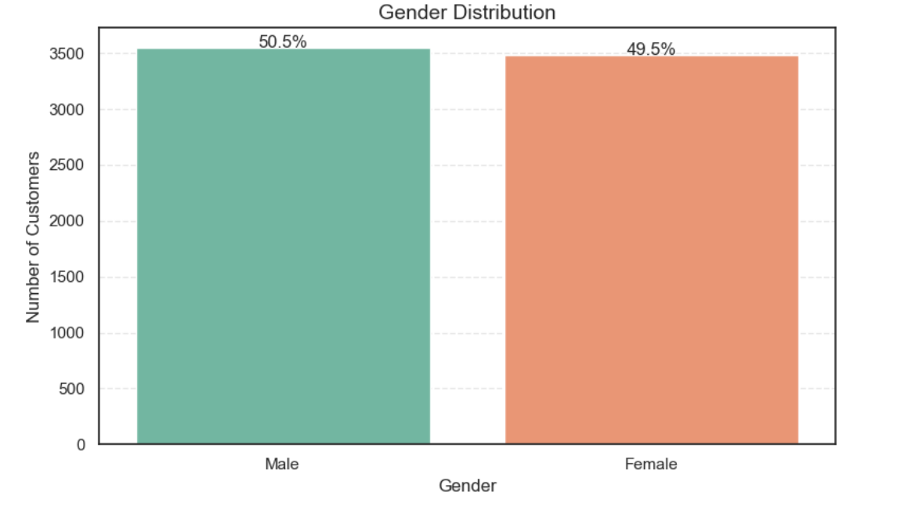
* **Senior Citizens**: Around 16% of customers are senior citizens, and they show a higher churn rate compared to younger customers. 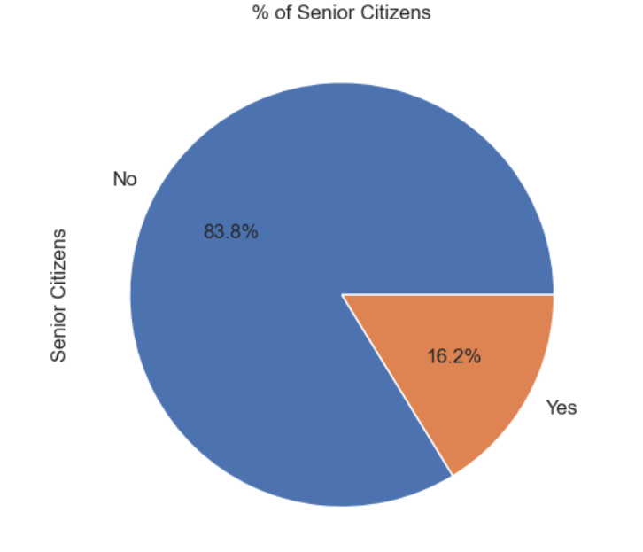
* **Partner and Dependents**: Customers without partners or dependents are more likely to churn.

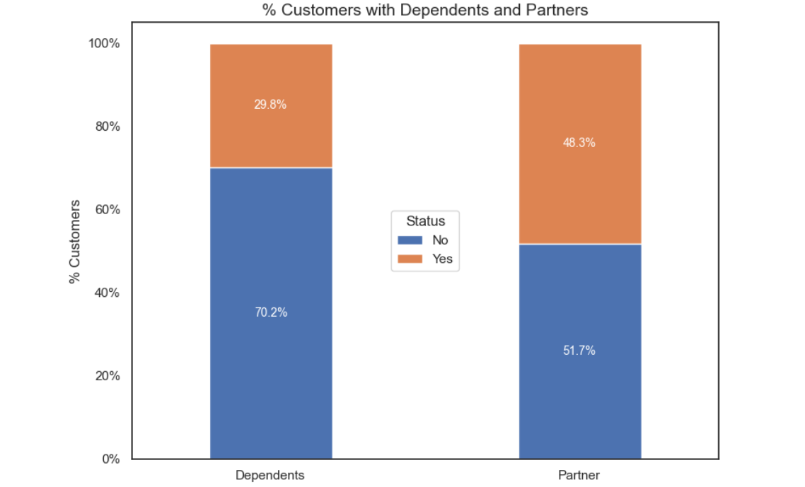

**B. Customer Account Information**

* **Tenure**: Most customers churn within the first 12 months. Longer-tenure customers are significantly less likely to leave.   
  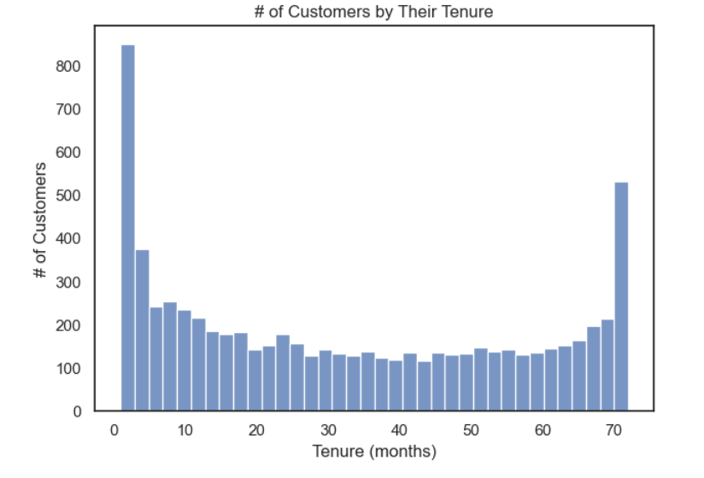
* **Contracts**: The majority of churners are on month-to-month contracts, while two-year contract customers show the lowest churn rates.  
  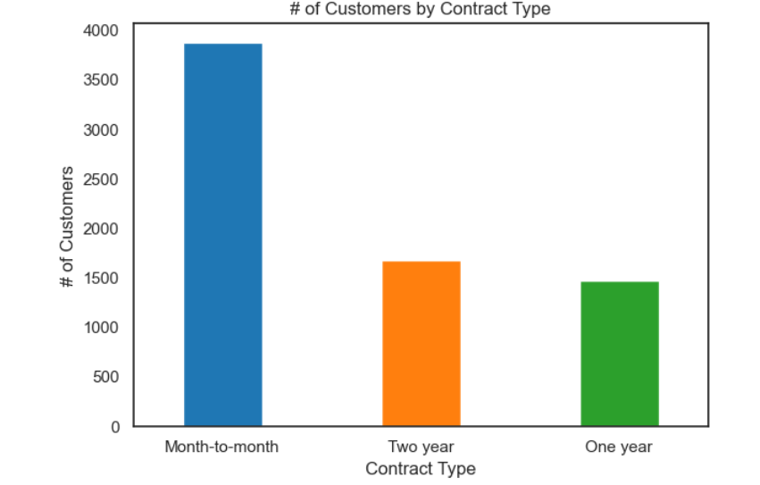
* **Churn by Contract Type**: Month-to-month customers account for the largest proportion of churn.  
    
  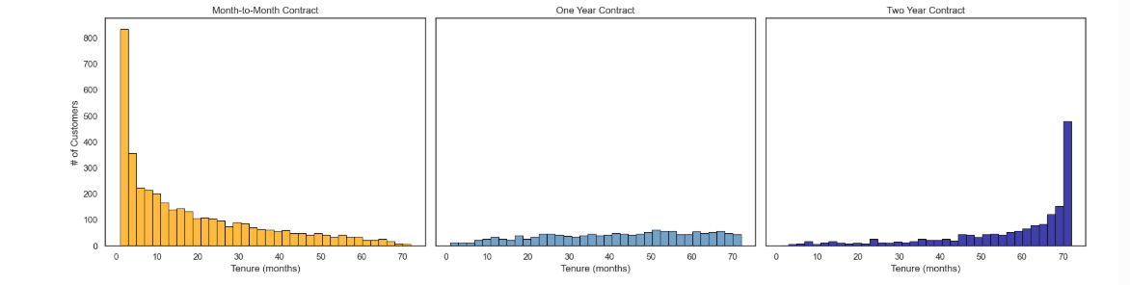

**C. Services Subscribed**

* Customers subscribing to **Fiber optic internet** have higher churn compared to DSL customers.
* Optional services such as **Online Security, Tech Support, and Device Protection** are associated with lower churn rates. *(Insert Grid of Charts)*

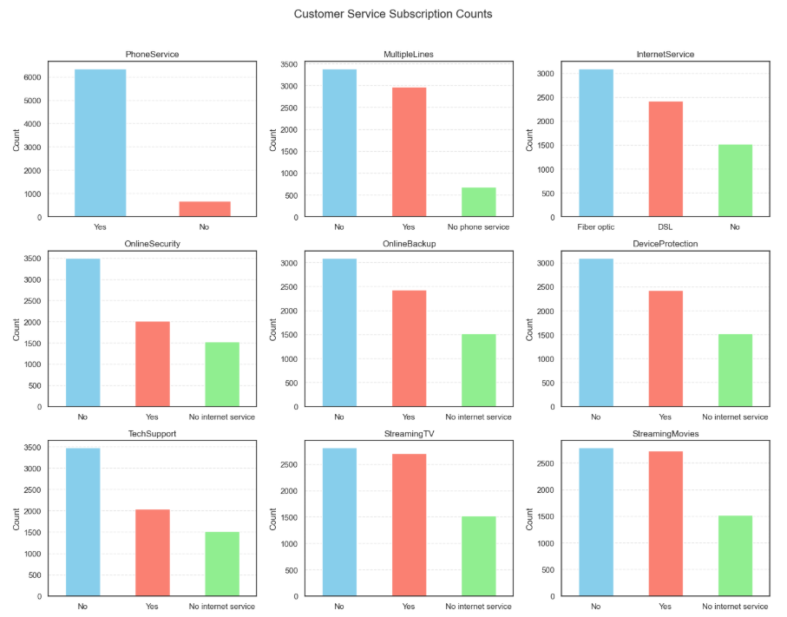

**D. Financial Information**

* **Monthly Charges**: Customers with higher monthly charges churn at higher rates. 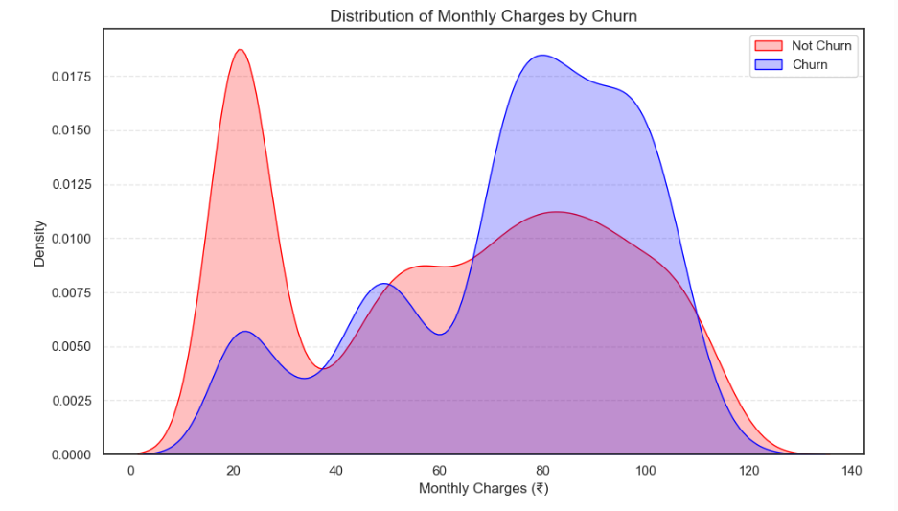
* **Total Charges**: Customers with lower total charges (often due to shorter tenure) are more likely to churn. 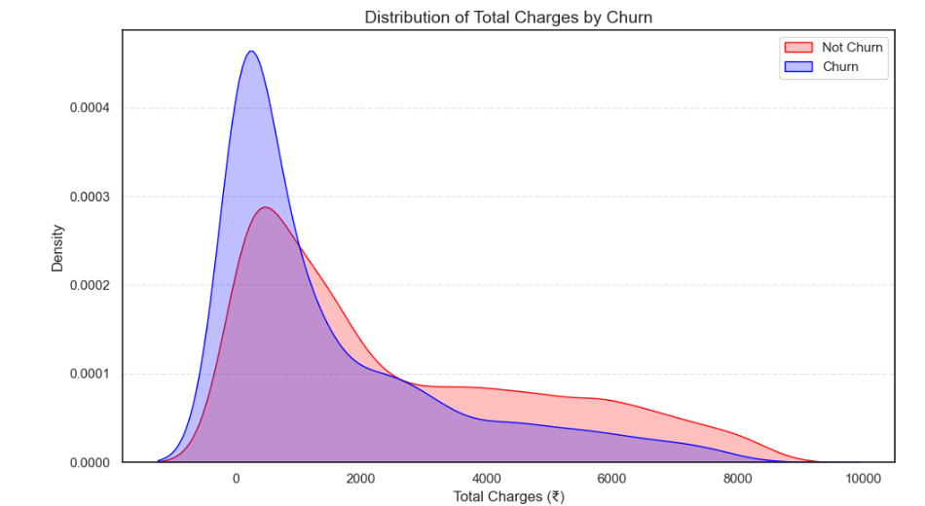
* **Monthly vs. Total Charges**: A positive correlation exists; however, churners tend to cluster in the high monthly / low total charges group. 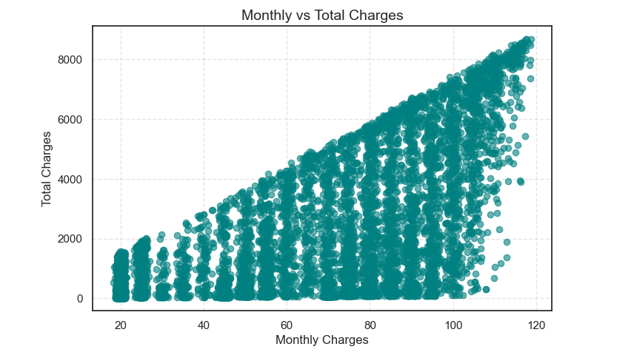

**E. Churn Insights**

* The overall churn rate in the dataset is **26.6%**. 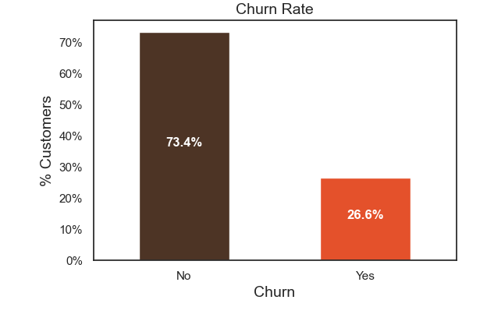
* **Churn vs. Tenure**: Customers with shorter tenure churn more frequently. 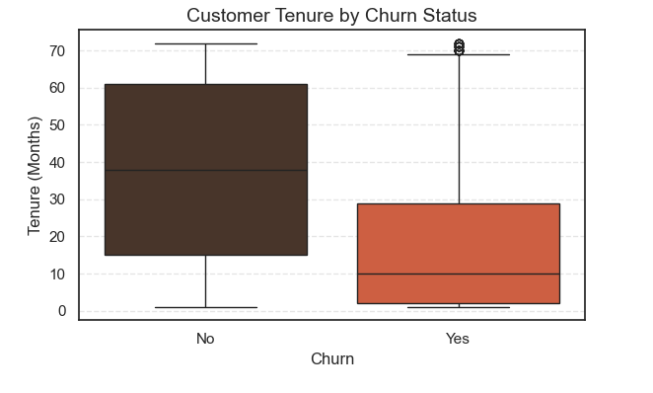
* **Churn vs. Senior Citizen Status**: Senior citizens exhibit higher churn compared to non-seniors. 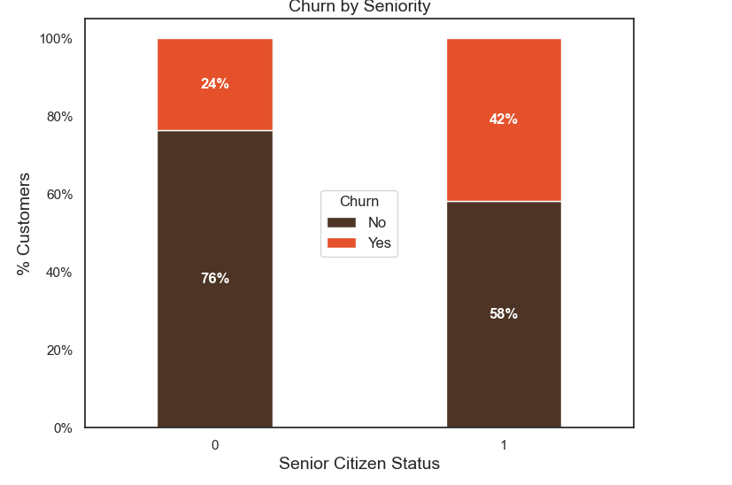
* **Churn vs. Contract**: Long-term contracts are a strong safeguard against churn. 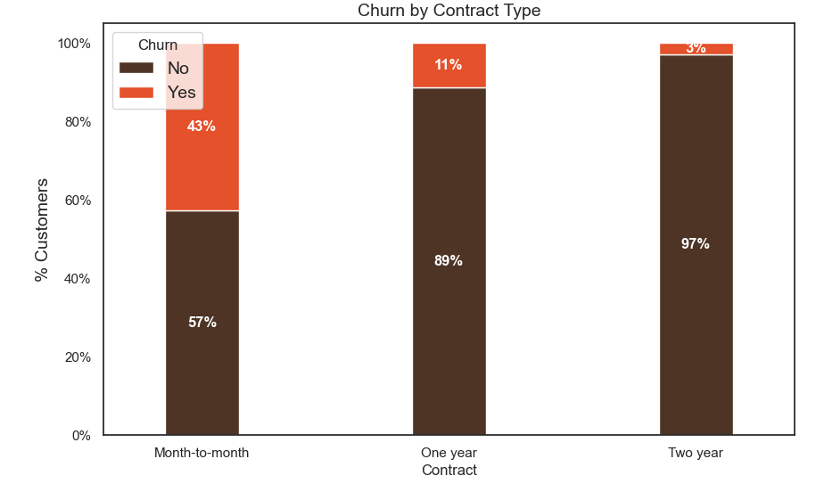

**4. Correlation Analysis**

Correlation analysis reveals that the strongest predictors of churn are:

* Contract type (month-to-month strongly linked with churn).
* Tenure (shorter tenure → higher churn).
* Monthly charges (higher charges → higher churn).
* Internet services (Fiber optic users churn more).

­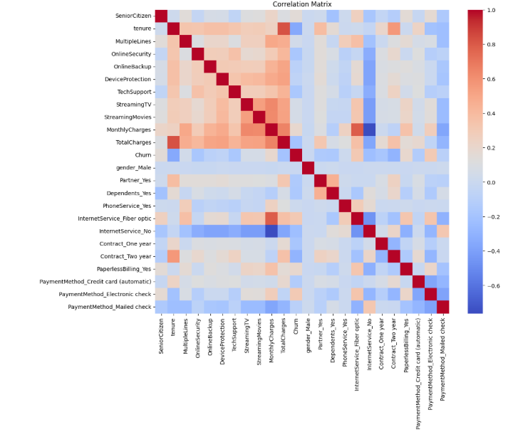

**5. Conclusion & Insights**

The analysis highlights several patterns in churn behavior:

* Customers on **month-to-month contracts** are most at risk of leaving.
* **High monthly charges** increase the likelihood of churn.
* **Electronic check payment method** is associated with higher churn.
* Customers with **short tenure** are more vulnerable.
* Senior citizens and customers without dependents or partners show higher churn.

**6. Recommendations**

Based on these findings, the following retention strategies are suggested:

1. **Encourage long-term contracts** by offering discounts and incentives.
2. **Provide price flexibility** for high monthly charge customers.
3. **Promote value-added services** (e.g., Online Security, Tech Support) that correlate with lower churn.
4. **Design onboarding and retention programs** for new customers in their first year.
5. **Targeted support for senior citizens** to address churn risk in this segment.